How to log method execution time using DryIOC with Interceptor of Castle.DynamicProxy2

Package needed in project



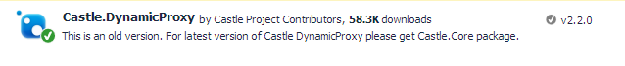

After adding above package in the project, go with below steps.

Step1: Create an interceptor class/or logger that will invoked every time method of IoC class called

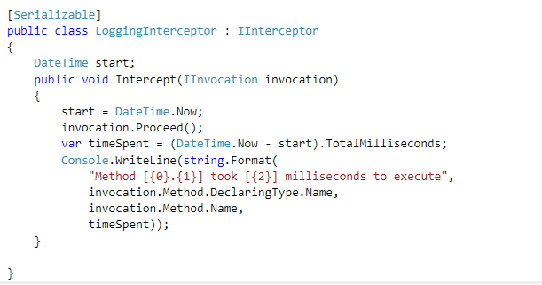

Step 2: DryIoC Interceptor extension

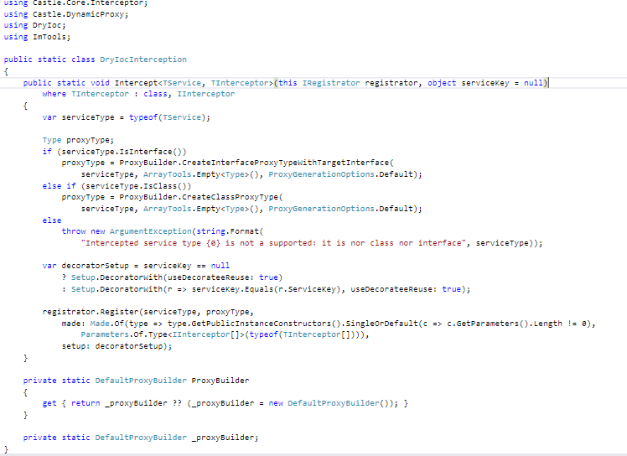

Step 3: Inject dependency in DryIoC

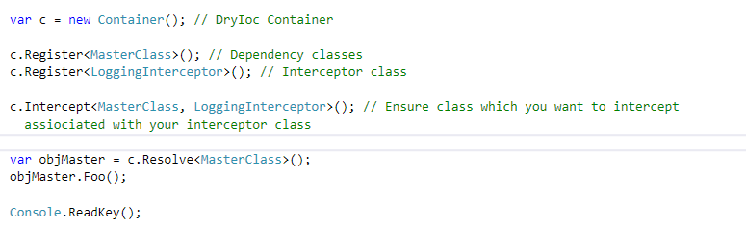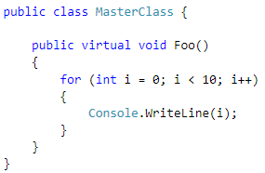

Result of above code

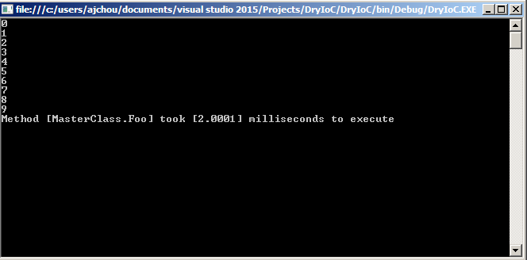

Thanks.